**Oleh :**

* **Suhendar 1127050153**
* **Irfan Ginanjar 1127050077**

**Buat State diagram dan Activity diagram untuk studi kasus Restoran Pizza**

**State Diagram “Pemesanan UI”**

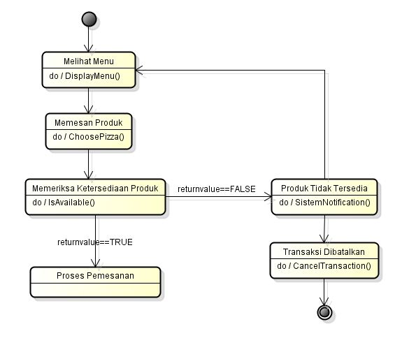

**State Diagram “PizzaController”  
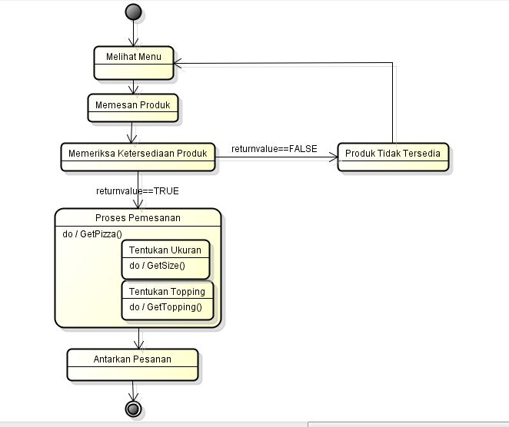  
State Diagram “Stok”**  
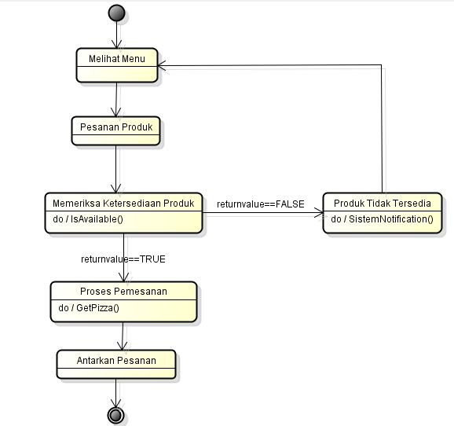

**State Diagram “Transaksi”**

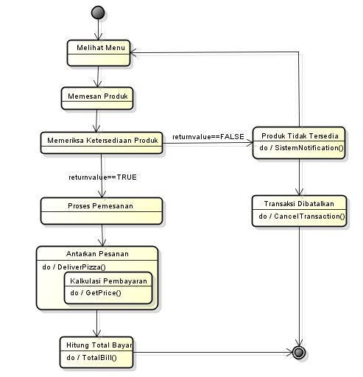

**Activity Diagram**

